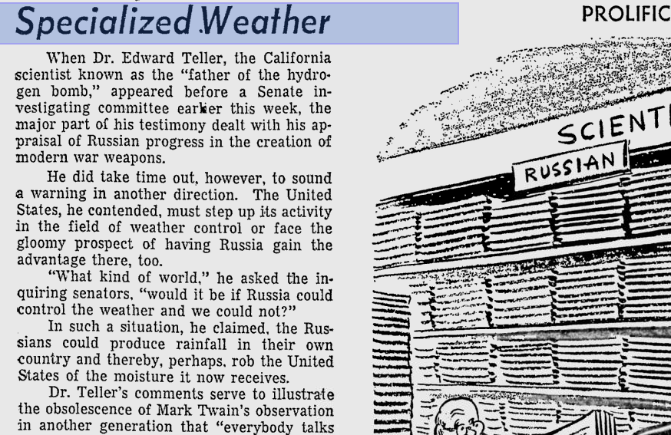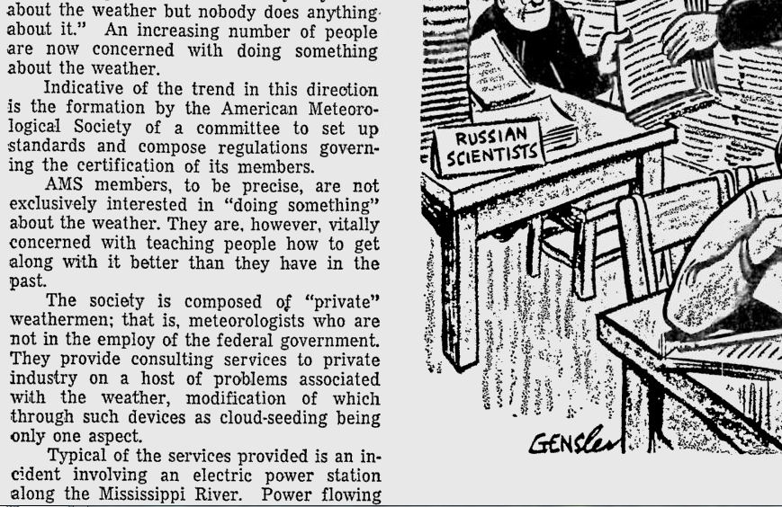

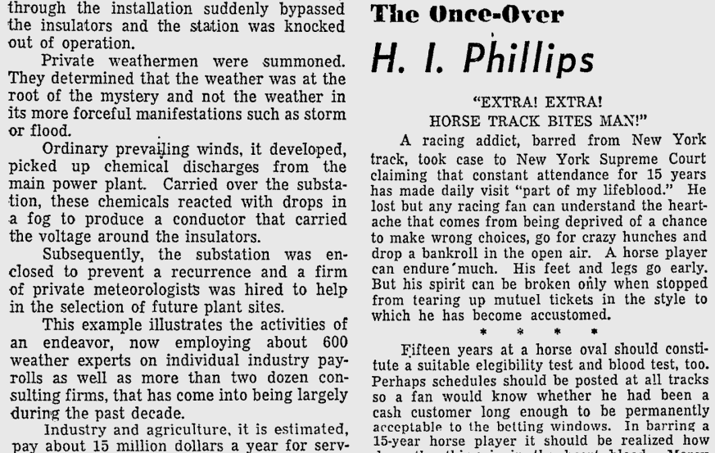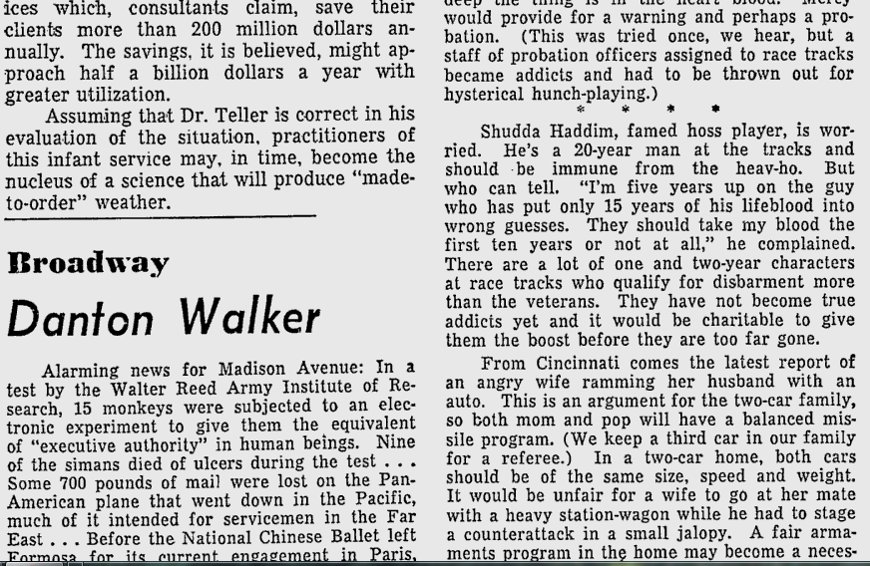
• Associate Press - Nov 1957. Specialized Weather: Modern War Weapons
http://news.google.com/newspapers?nid=1955&dat=19571127&id=MYYtAAAAIBAJ&sjid=Q5oFAAAAIBAJ&pg=5268,4975448

